

LAB REPORT

Submitted by:
Name: Esha Silvia Rozario
ID: 0692220005101004
Batch: CSE 19
Date: 04-12-22
Course: CSE LAB
Course Code: 1202

Submitted to:
A.H.M Saiful Islam
Associate Professor, Chairman
Department of CSE, NDUB

INDEX

LAB 01

INTRODUCTION TO C

NAME OF PROBLEMS: PAGE

[1] Write a program with C which display “We are CSE students.” --------------1

[2] Write a program with C which display,” Varsity, CSE, Your name, Code.”----1

[3] Write a program with C which display, F(letter) using # --------------------1

[4] Write a program with C which display, A(letter) using # ---------------------2
[5] Write a program with C which display, C(letter) using # ---------------------2

[6] Write a program with C which display, multiplication table of 5 for 10
times.-------------------------------------------------------------------------------2

[7] Write a program with C which display, square with {-} & rhombus with {/}.-3

LAB 02

GENERAL PROBLEMS

NAME OF PROBLEMS: PAGE
[1] Input two numbers from the keyboard, find out the summation of two numbers. -------------------------------------------------------------------------4

[2] Find out the area of a Rectangle shaped Room. ----------------------------4

[3] Find out the area of a Square shaped Room. -------------------------------5

[4] Write down all three programs from P1 to P3 in a single code. -----------5

[5] There were 4687 people in a village in the last year. In this year, 349 people moved in and 280 people moved out of the village. how many people are there in this year?------------------------------------------------------------6

[6] A butcher sells beef at 700 Taka per kg and mutton at 800 Taka per kg. If we buy 3 kg of beef and 2 kg of mutton, and pay 4000 Taka, how much will be the change? ---------------------------------------------------------------------6
[7] Mr. X’s monthly salary is P Taka. Every month he spends A Taka for house rent, B Taka for household expenses. He saves the remaining money in a bank. What amount of money does Mr. X save in a year? ---------------------------7
[8] M and R together have X amount of Taka. M has 550 Taka more than R. How much money does M and R each has? You have to input the total amount of money. -----------------------------------------------------------------------7
[9] M and R together have 8500 Taka. M has 480 Taka less than R. how much money does M and R each has? -----------------------------------------------8
[10] The sum of ages of a Father and his daughter is 80 years. Father’s age is four times the age of the daughter. What are their ages? ---------------------8
[11] The price of 2 cows and 3 goats together is 98050 Taka. The price of 1 goat is 6800 Taka. what is the price of one cow? -------------------------------9

LAB 03

ARITHMETIC OPERATORS

NAME OF PROBLEMS: PAGE

[1] Write a C program to convert a given integer (in seconds) to hours, minutes and seconds.
Sample Input:
Input seconds: 25300
Sample Output: There are:
H:M:S - 7:1:40 -----------------------------------------------------------------10
[2] Write a C program to convert specified days into years, weeks and days. Ignore leap year.
Sample Input:
Number of days: 1329
Sample Output:
Years: 3
Weeks: 33
Days: 3 ------------------------------------------------------------------------10
[3] Write a C program to convert a given integer (in days) to years, months and days, assume that all months have 30 days and all years have 365 days.
Sample Input:
Input no. of days: 2535
Sample Output:
6 Year(s)
11 Month(s)
15 Day(s) ----------------------------------------------------------------------11
[4] Write a C program to calculate a bike’s average consumption from the given total distance (integer value) traveled (in km) and spent fuel (in litres, float number – 2 decimal point).
Sample Input:
Input total distance in km: 350
Input total fuel spent in liters: 5
Sample Output:
Average consumption (km/L) 70.000 ----------------------------------------12
[5] There are X grams of rice at home. If we eat Y(Y<X) grams of rice every day, when the rice will be finish? --------------------------------------------13
[6] N pieces of papers are necessary to prepare one book, how many books can be prepared by M(M>N) pieces of papers? ----------------------------13
[7] A company gained profit of 95200 Taka in business and wanted to distribute this money equally to its employees. If 800 taka was given to each employee, how many employees are there in the company? ---------------14
[8] Generalize the problem [7]. ----------------------------------------------14
[9] Every 250 products are packed in one cardboard box. In order to pack 43548 products, how many boxes will be necessary? -----------------------15
[10] Generalize the problem [9]. ---------------------------------------------15
[11] The price of 8 eggs is 72 Taka. If we buy 15 pieces of eggs, how much do we need to pay? -----------------------------------------------------------16
[12] Generalize the problem [11]. --------------------------------------------17
[13] If the price of 4 bananas is 80 Taka, how much is the price for 10 bananas? ----------------------------------------------------------------------17
[14] Generalize the problem [13] --------------------------------------------18
[15] Aysha bought 8 pencils at 64 Taka. How much will she pay if she buys 24 pencils?------------------------------------------------------------------------19
[16] Generalize the problem [15]. --------------------------------------------19
[17] Write a program to calculate the sum of the first and the second last digit of a 5 digits number entered from the keyboard. ---------------------20
LAB 04

CONDITIONAL AND OTHER OPERATORS

NAME OF PROBLEMS: PAGE

[1] Write a C program to find the maximum in the given two numbers using the conditional operator. -----------------------------------------------------21
[2] Write a C program to find the inputted number is positive or negative using the conditional operator. ----------------------------------------------22
[3] Write a C program to check whether the given number is odd or even using the conditional operator in C. -----------------------------------------22
[4] Write a C program to find the minimum of two numbers using the conditional operator.----------------------------------------------------------23
[5] Write a program to enter two numbers. Make a comparison between them with the conditional operator. If the first number is greater than the second, perform a division operation otherwise multiplication operation.--23
[6] Use the conditional operator to produce a code to have the following sample input and output:
Sample Output for the different test-cases: -
Enter the number of items: 1
You have 1 item.
Enter the number of items: 2
You have 2 items.---------------------------------------------------------------24
[7] Find the largest among three numbers using the conditional operator--24
[8] Length and breadth of a rectangle are 5 and 7 respectively. Write a program to calculate the area and perimeter of the rectangle.---------------25
[9] Write a program to input the value of the radius of a circle from keyboard and then calculate its perimeter and area.------------------------------------25
[10] Write a program to enter a 4 digits number from keyboard. Add 8 to the number and then divide it by 3. Now, the modulus of that number is taken with 5 and then multiply the resultant value by 5. Display the final result.---26
[11] Now, solve the above question, [3] using assignment operators (e.g. +=, -=, *=). ------------------------------------------------------------------------ 26
[12] Enter two numbers from keyboard. Write a program to check if the two numbers are equal.-------------------------------------------------------------27
[13] Write a program to enter the values of two variables 'a' and 'b' from keyboard and then check if both the conditions 'a < 50' and 'a < b' are true.27
[14] Now solve the above question [6] to check if at least one of the conditions 'a < 50' and 'a < b' is true.------------------------------------------------------28
[15] Write a program to convert Fahrenheit into Celsius.---------------------29
[16] Write a program to calculate the sum of the digits of a 3 digits number which is entered from keyboard.---------------------------------------------- 29
LAB 05

IF, ELSE IF LADDER

NAME OF PROBLEMS: PAGE

[1] Admission to a professional course in subject to the
following conditions:
Marks in mathematics >=60
Marks in Physics >=50
Marks in Chemistry >=40
Total in all three subjects >=200
or
Total in mathematics and physics>=150
Given the marks in the three subjects, write a program in C to process the applications to list the eligible candidates.------------------------------------31
[2] An electric power distribution company charges its domestic
consumers as follows:
Consumption Units Rate of Charge
0 - 200 BDT 0.50 per unit
201 - 400 BDT 100 plus BDT 0.65 per unit excess of 200
401 - 600 BDT 230 plus BDT 0.80 per unit excess of 400
601 and above BDT 390 plus BDT 1.00 per unit excess of 600
Write a program to read number of units consumed and print
out the amount to be paid by the customer.---------------------------------31
[3] The problem is attached in the image:
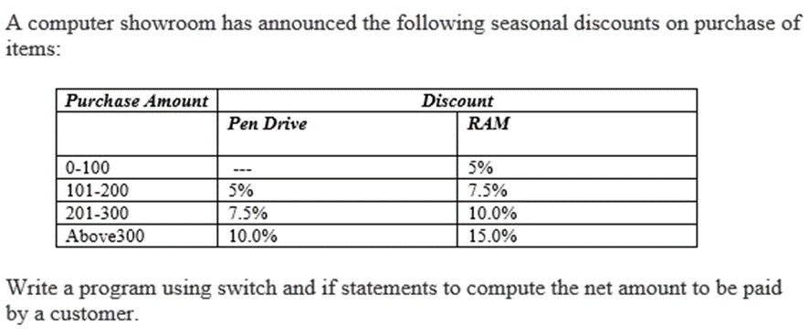--------------------------33

[4] Take values of length and breadth of a rectangle from user and check if it is square or not. ---------------------------------------------------------------35
[5] Take two int values from user and print greatest among them.----------36
[6] Write a C program to input amount from user and print minimum number of notes (TK. 1000, 500, 100, 50, 20, 10, 5, 2, 1) required for the amount. ------------------------------------------------------------------------37

LAB 06

SWITCH STATEMENT

NAME OF PROBLEMS: PAGE

[1]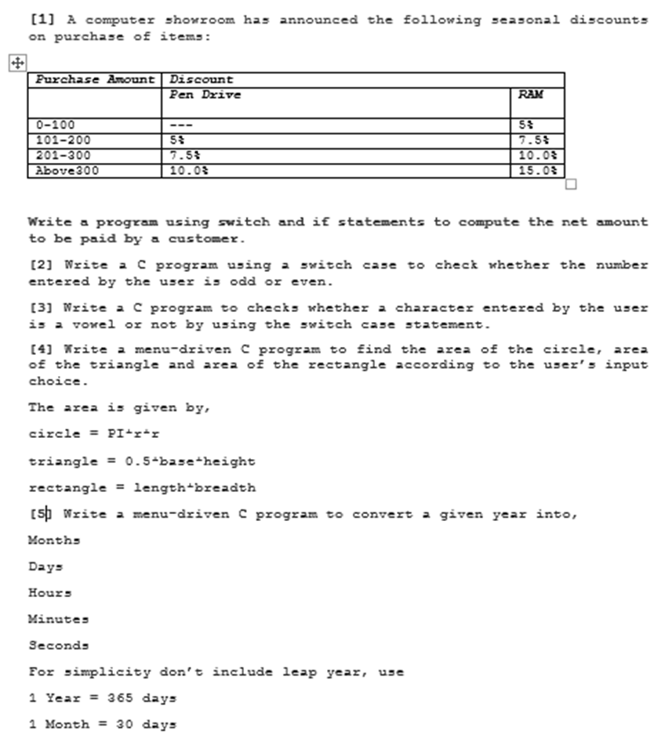
A computer showroom has announced the following seasonal discount on purchase of items. Write a program using switch and if statements to computer the net amount to be paid by a customer.-------------------------39

[2] Write a C program using a switch case to check whether the number entered by the user is odd or even.--------------------------------------------42

[3] Write a C program to check whether a character entered by the user is a vowel or not by using the switch case statement. -----------------------------43

[4] Write a menu-driven C program to find the area of the circle, area of the triangle and area of the rectangle according to the user’s input choice.
The area is given by,
circle = PI*r*r
triangle = 0.5*base*height
rectangle = length*breadth ----------------------------------------------------44

[5] Write a menu-driven C program to convert a given year into,
Months Days Hours Minutes Seconds.
For simplicity don’t include leap year.
Use:
1 Year = 365 days
1 Month = 30 days ------------------------------------------------------------46

LAB 07

NESTED LOOPS

NAME OF PROBLEMS: PAGE

[1] Print 1 to 10 using for loop. -------------------------------------------------47

[2] Print even numbers between 1 to 10 using loop. --------------------------47

[3] Print odd numbers between 1 to 10 using loop. ---------------------------48

[4] Print the number of even numbers between 1 to 10 using loop. ----------48

[5] Print the number of odd numbers between 1 to 10 using loop. ----------49

[6] Summation of 1 to 5 using loop. --------------------------------------------50

[7] Sum of all even numbers between 1 to 10. ---------------------------------50

[8] Sum of all odd numbers between 1 to 10. ---------------------------------51

[9] Run all the above 8 codes in one code. ------------------------------------51

LAB 08

ARRAY

NAME OF PROBLEMS: PAGE

[1] Display the array element. --------------------------------------------------57

[2] Show the square of each array element. -----------------------------------57

[3] Display the even number of an array. --------------------------------------58

[4] Display the odd number of an array. ---------------------------------------59

[5] Count the even number of the array. --------------------------------------60

[6] Count the odd number of the array. ---------------------------------------61

[7] Show the summation of the array element. --------------------------------62

[8] Show all above 7 codes in one. ---------------------------------------------63

